Chapter 13, Problem 29.

In the circuit of Fig. 13.98, find the value of the coupling coefficient k that will make the 10-Ω resistor dissipate 320 W. For this value of k, find the energy stored in the coupled coils at t = 1.5 s.

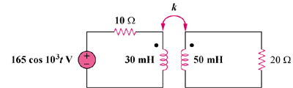

Figure 13.98
For Prob. 13.29.

